Name of CSO / NGOs / PO ___________________________________________________________________________
ACRONYM ________________________________________ Number of Years of Operation _____________

* For CSO/PO operating for more than three (3) years, for submission are:
LIST OF SUBMITTED DOCUMENTARY REQUIREMENTS | Submitted |  | Date Submitted | Remarks / Status
 | YES | NO
- Duly accomplished Application Form
- Certificate of Registration (attach photocopy) from either SEC, CDA, DSWD, or other government agencies
- Authenticated copy of the latest Articles of Incorporation, or the Articles of Cooperation, as the case may be, showing the original incorporators/organizers and the Secretary’s Certificate for incumbent officers, together with the certificate of filing with SEC/certificate of Approval by the CDA and the General Information Sheet in the case of SEC registration
- Organizational Structure of the Proponent and List of Officers with address and Bio-data
- Location Map
- Omnibus Sworn Statement and Undertaking (attached Form from CHR)
- Financial Reports, preferably audited by an independent Certified Public Accountant, for the past 3 years preceding the date of project implementation
- Certificate of Good Standing from the Government Agency from which the organization received public funds (if any)
- Printed copy of its PhilGEPS Online Registration

• For CSO/PO operating for less than three (3) years, for submission are:
LIST OF SUBMITTED DOCUMENTARY REQUIREMENTS | Submitted |  | Date Submitted | Remarks / Status
 | YES | NO
- Items 1 - 6 as above
- Report of accomplishment or any equivalent proof certified by its President and Secretary that it had previously implemented similar projects (if any )
- Financial reports for the years it has been in operation and existing active bank account/s through a photocopy/scanned copy of bank book with complete bank account information of the organization (bank account name, number and branch)
- List and/or photographs of similar projects and their status, the applicant or proponent is implementing or has previously undertaken including sources of funds if any
- Printed copy of its PhilGEPS Online Registration

• For CSO/PO renewal of accreditation, for submission are:
LIST OF SUBMITTED DOCUMENTARY REQUIREMENTS | Submitted |  | Date Submitted | Remarks / Status
 | YES | NO
- Duly accomplished Application Form
- Certificate of Registration (attach photocopy) from either SEC, CDA, DSWD, or other government agencies
- Authenticated copy of the latest Articles of Incorporation, or the Articles of Cooperation, as the case may be, showing the original incorporators/organizers and the Secretary’s Certificate for incumbent officers, together with the certificate of filing with SEC/certificate of Approval by the CDA and the General Information Sheet in the case of SEC registration
- Financial Reports, preferably audited by an independent Certified Public Accountant, for the past year preceding the date of expiration of accreditation
- Printed copy of its PhilGEPS Online Registration
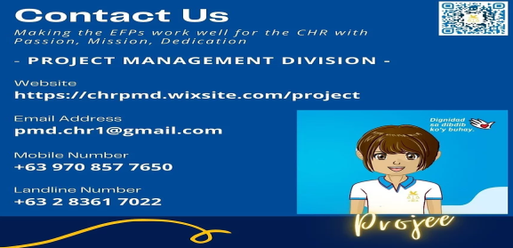
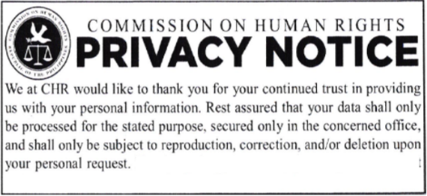
Reviewed as to completeness of submission:

